Krill Oil: What is it good for?

SUPPLEMENT

Adding supplements to your daily diet can be quite beneficial. Especially if you or your family has been known to have ailments that effect your day to day lifestyle. For many athletes, it can be difficult to help find the right supplements to benefit their health and improve their progressing workout sessions.

One supplement that many people overlook due to the creature the nutrients is extracted from, is Kill Oil. Krill oil is taken from Antarctic Krill and has many benefits, some out weighing fish. The large amounts of Omega-3’s found in krill oil is so important to helping fight diabetic, inflammatory, and cardiovascular diseases. The amounts of omega-3 found in krill oil is more potent, leaving the supplements far smaller than fish oil vitamins. No one likes a clunky vitamin.

Other benefits of krill oil include:

* Gentle on the stomach and eliminates fishy burps
* Readily absorbed by the body which allows smaller capsules
* Clean option, containing no additives or preservatives
* Naturally includes choline, which may aid sports performance
* Helps boosts mood and is used in treating anxiety and depression
* Helps lower cholesterol and boosts a healthy blood pressure
* Known to help combat arthritis and ease stress in joints

Do these benefits sound good to you? Interested in trying some yourself? Here are brands we recommend for beginners:

**Krill Oil Platinum by 1MD**

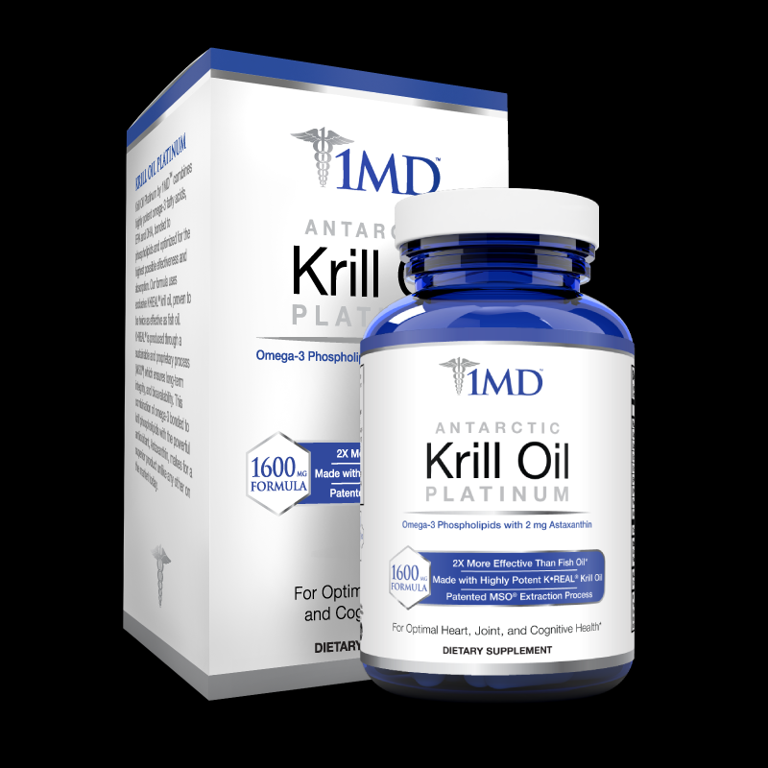

**MegaRad**

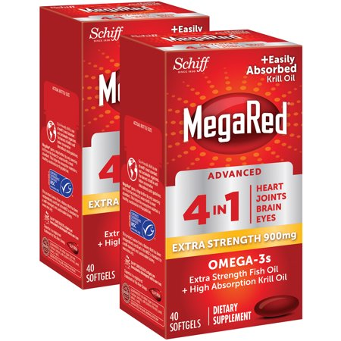

**Piping Rock**

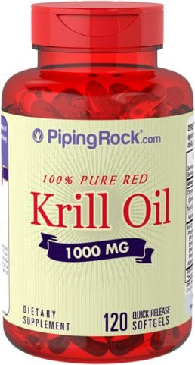

**Sports Research**

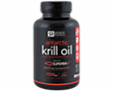

Most people can get enough nutrients from a healthy, varied diet. These product aids in the boosting the lack of dietary nutrients from normal daily consumption. Be sure to always read the ingredients label while some supplements contain artificial or ingredients and can be harmful to those with allergies. Shellfish allergies are quite common and those who suffer should not consume krill oil as a daily supplement.